MongoDB Lab

Exercise 1:

1. Load sample data

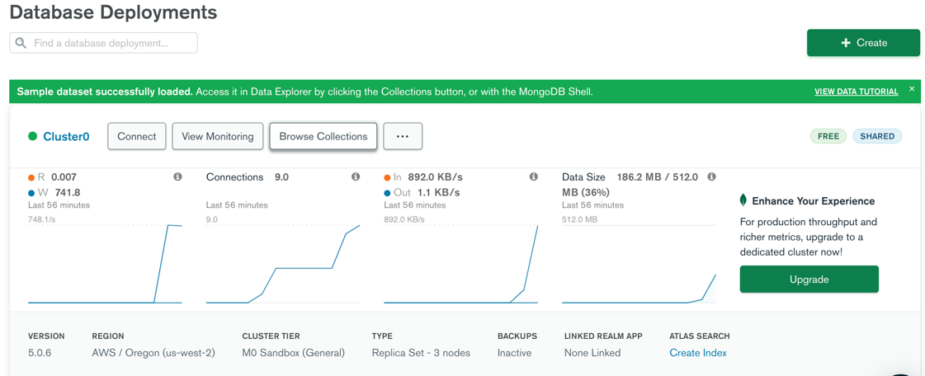

1. Using your mongo shell, list your databases, select the sample_weatherdata set, then show collections within that:
   1. show dbs;



* 1. use sample_weatherdata;



* 1. show collections;



1. This should show you there is a data collection within that database. Find all documents in the collection, then display them using the .pretty() flag, and finally count them:
   1. db.data.find();

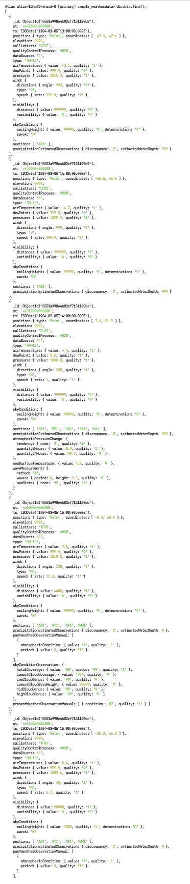

(only partial screenshot… continued on for a few more pages…)

* 1. db.data.find().pretty();

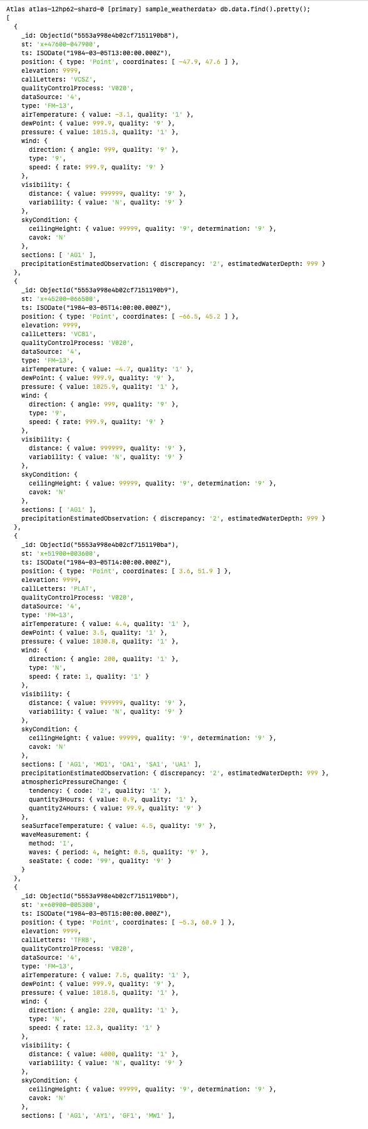

(only partial screenshot… continued on for a few more pages…)

* 1. db.data.find().count();



1. Search for all documents containing a skyCondition.ceilingHeight.value of 750 and count the results. Then display the results:
   1. db.data.find({"skyCondition.ceilingHeight.value":750}).count();



* 1. db.data.find({"skyCondition.ceilingHeight.value":750}).pretty();

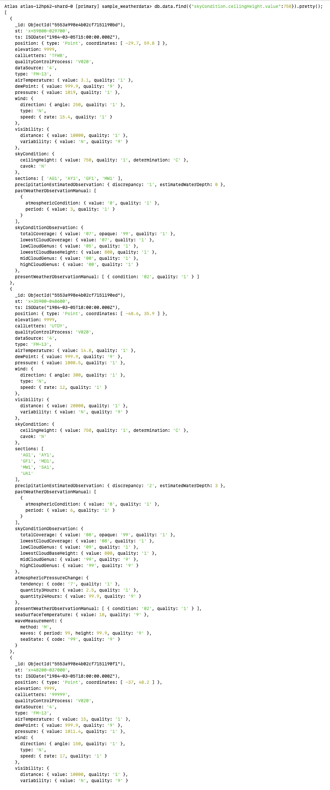

(only partial screenshot… continued on for a few more pages…)

1. Retrieve a single document based on ObjectId:
   1. db.data.find(ObjectId("5553a998e4b02cf7151195d3")).pretty();

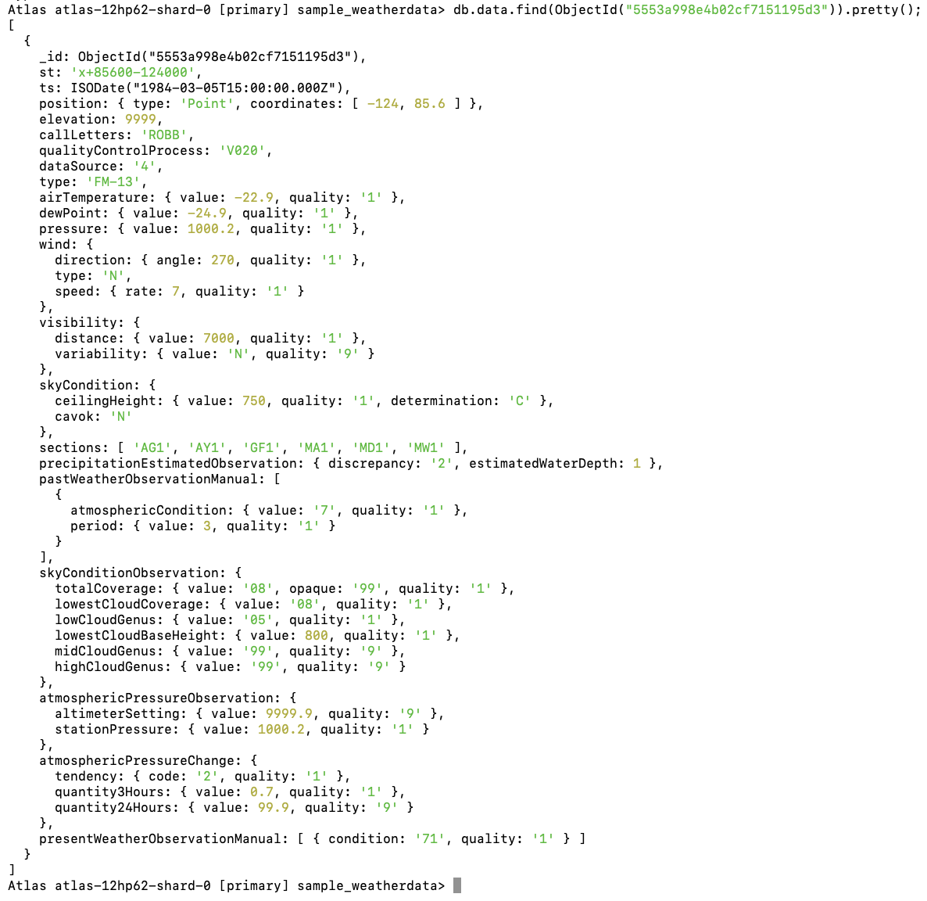

1. Finally, using the code below insert a new document. After insertion, can you retrieve this document?

db.data.insertOne({

"st" : "x+85600-124000",

"ts" : ISODate("1984-03-07T13:00:00Z"),

"position" : {

"type" : "Point",

"coordinates" : [

-124,

85.6

]

},

"elevation" : 8787,

"callLetters" : "ROBZ",

"qualityControlProcess" : "V020",

"dataSource" : "3",

"type" : "FM-13",

"airTemperature" : {

"value" : -22.9,

"quality" : "1"

},

"dewPoint" : {

"value" : -24.9,

"quality" : "1"

},

"pressure" : {

"value" : 1000.2,

"quality" : "1"

},

"wind" : {

"direction" : {

"angle" : 270,

"quality" : "1"

},

"type" : "N",

"speed" : {

"rate" : 7,

"quality" : "1"

}

},

"visibility" : {

"distance" : {

"value" : 7000,

"quality" : "1"

},

"variability" : {

"value" : "N",

"quality" : "9"

}

},

"skyCondition" : {

"ceilingHeight" : {

"value" : 760,

"quality" : "1",

"determination" : "C"

}

}

});

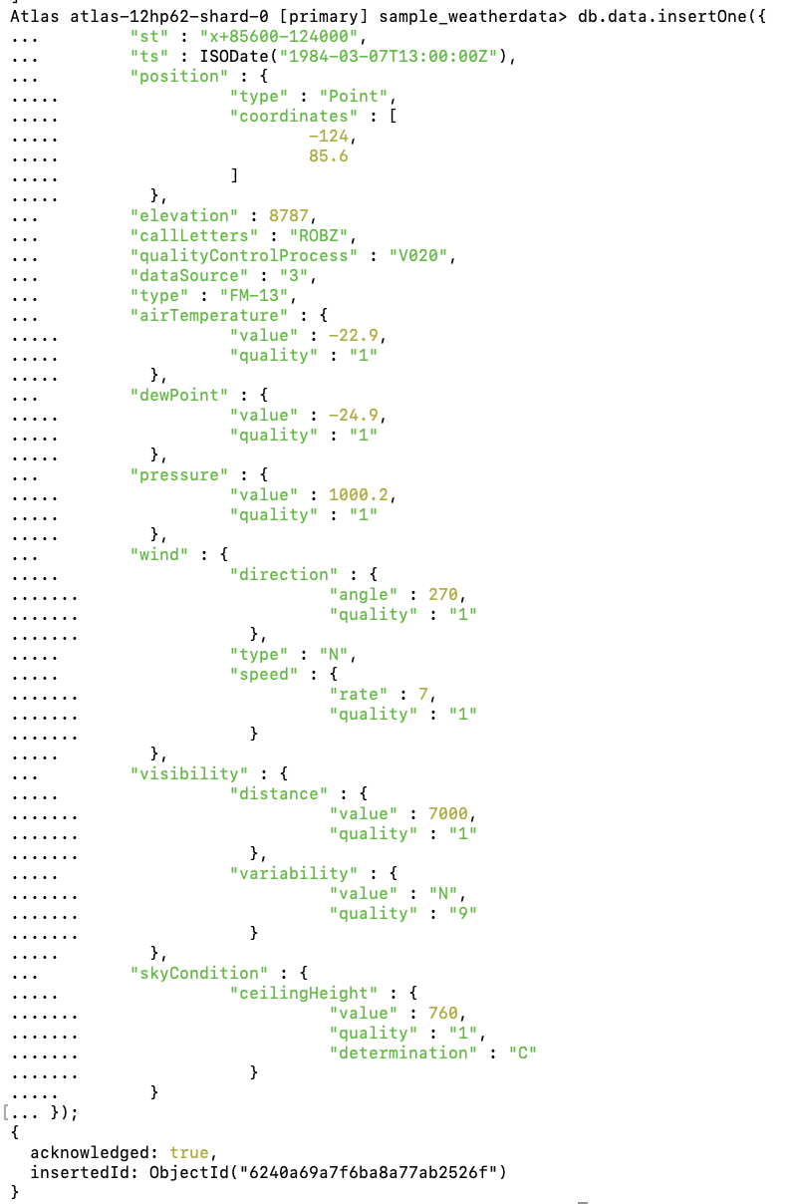

db.data.find({"skyCondition.ceilingHeight.value":760}).pretty();

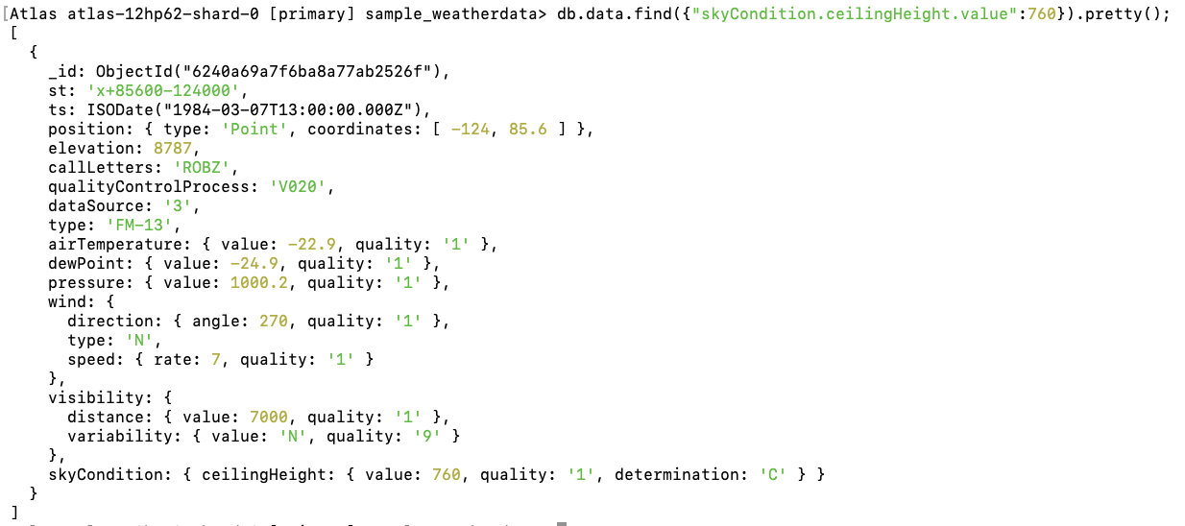

(to find the data that was just inserted ran this^^)